AI Disclosure and Contribution Record.
AI tools were used to support the planning, design, documentation and development of the prototype. All AI generated outputs were reviewed and validated by the project team.
Glide AI was used for the interface layout suggestion and application setup assistance.
AI-Assisted Development Activities

Prompt/Assistance Summary | Output used | Human modification/ Validation
Define customer and staff permission | Role and permission Recommendations | Specify what each role should get access to.
Create interface based on info provided | Request form created with some data entry fields | Modified screens to collect specific data designed by Graphic Gala
Create a screen to showcase services | Service display screen generated. | Included specific services offered by Graphic Gala along with images to represent each.
Create a tracking status field | Initial tracking screen was generate | Specify that customer must be able to enter the reference and view project status and detail.
Recommend a workflow for handling design requests, revisions, approvals, and project completion. | Suggested workflow stages and status progression. | Adapted workflow to match business operations and implemented status tracking within Glide.
Suggest dashboard metrics for monitoring requests and workload. | Recommendations for status-based reporting metrics. | Implemented metrics relevant to request volume, progress, review status, and completed projects.

Developers Contribution
The project team was responsible for configuring the Glide application, creating and maintaining tables, implementing workflow actions, configuring user roles and permissions, designing dashboard views, testing functionality, and validating all AI-generated recommendations before implementation. AI-generated outputs were used as suggestions and were modified where necessary to meet the project requirements.

Verification and Validation
All AI-generated outputs were reviewed against the project requirements before implementation. Workflow actions, user permissions, dashboard metrics, and tracking features were manually tested within the Glide prototype to ensure they functioned as intended.

Screenshot of Prompts
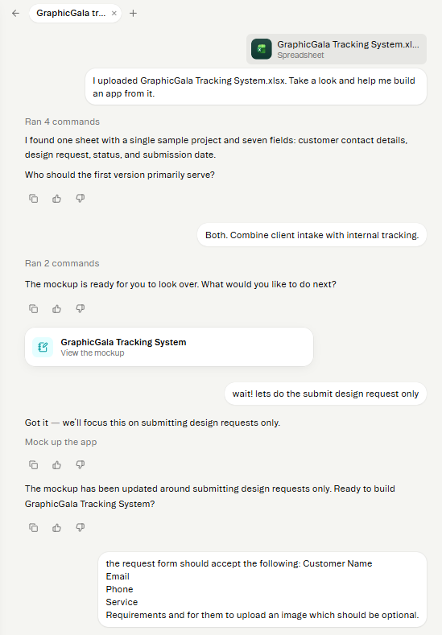
Figure 1 Showing prompt for updating what information should exist in the request design screen.
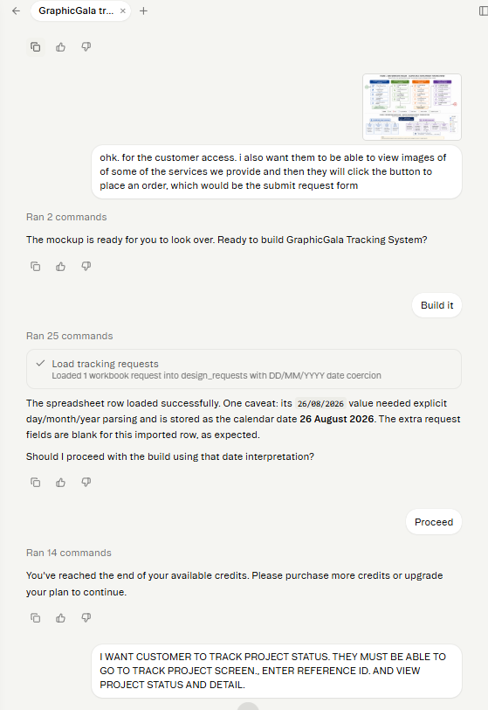
Figure 2. Showing prompt for Tracking project status
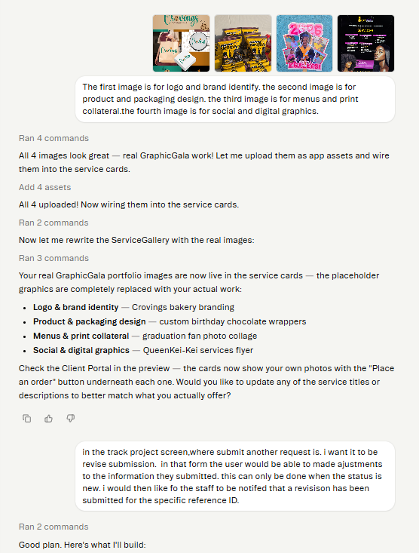
Figure 3. Showing prompt for adding and updating services and imags

